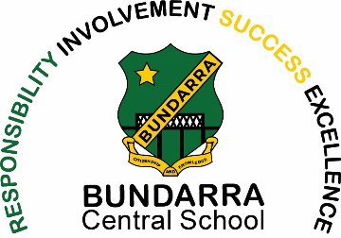
Bundarra Central School
Bowline Street
BUNDARRA NSW 2359
Phone 026723 7102
Fax 02 6723 7387
Email Address bundarra-c.school@det.nsw.edu.au
.

9th November 2022

Dear Parents/Caregivers

Back to School Book Packs 2023

This year the school will be preparing Book Packs for families to purchase for their convenience, you may
Purchase these through the office or supply your own required items listed below.
Pricing is as accurate as possible, however, may change without notice.
Please use 1 order form per child and indicate quantity required.

Students in Kindergarten will receive a complimentary school library bag and hat.

Years K/1/2
Name: |  | Quantity | Total price
Document Wallet | $0.55
Bostick Glue Stick (35g) | $1.50
Art Smock | $10.75
Highlighters (6) | $1.95
Whiteboard Markers (4) | $1.20
Tissues | $0.60
NSW Targeting Maths Textbook (Required) | $18.00
 |  | Total | $
Please return completed order form by the 25^{th of} November 2022, please do not include money with this order form the office with let you know when your items have arrived.

________________ __________________ ___/11/2022
(parent/caregiver name) (parent/caregiver signature)

Mr Justin Stewart
Relieving Principal

